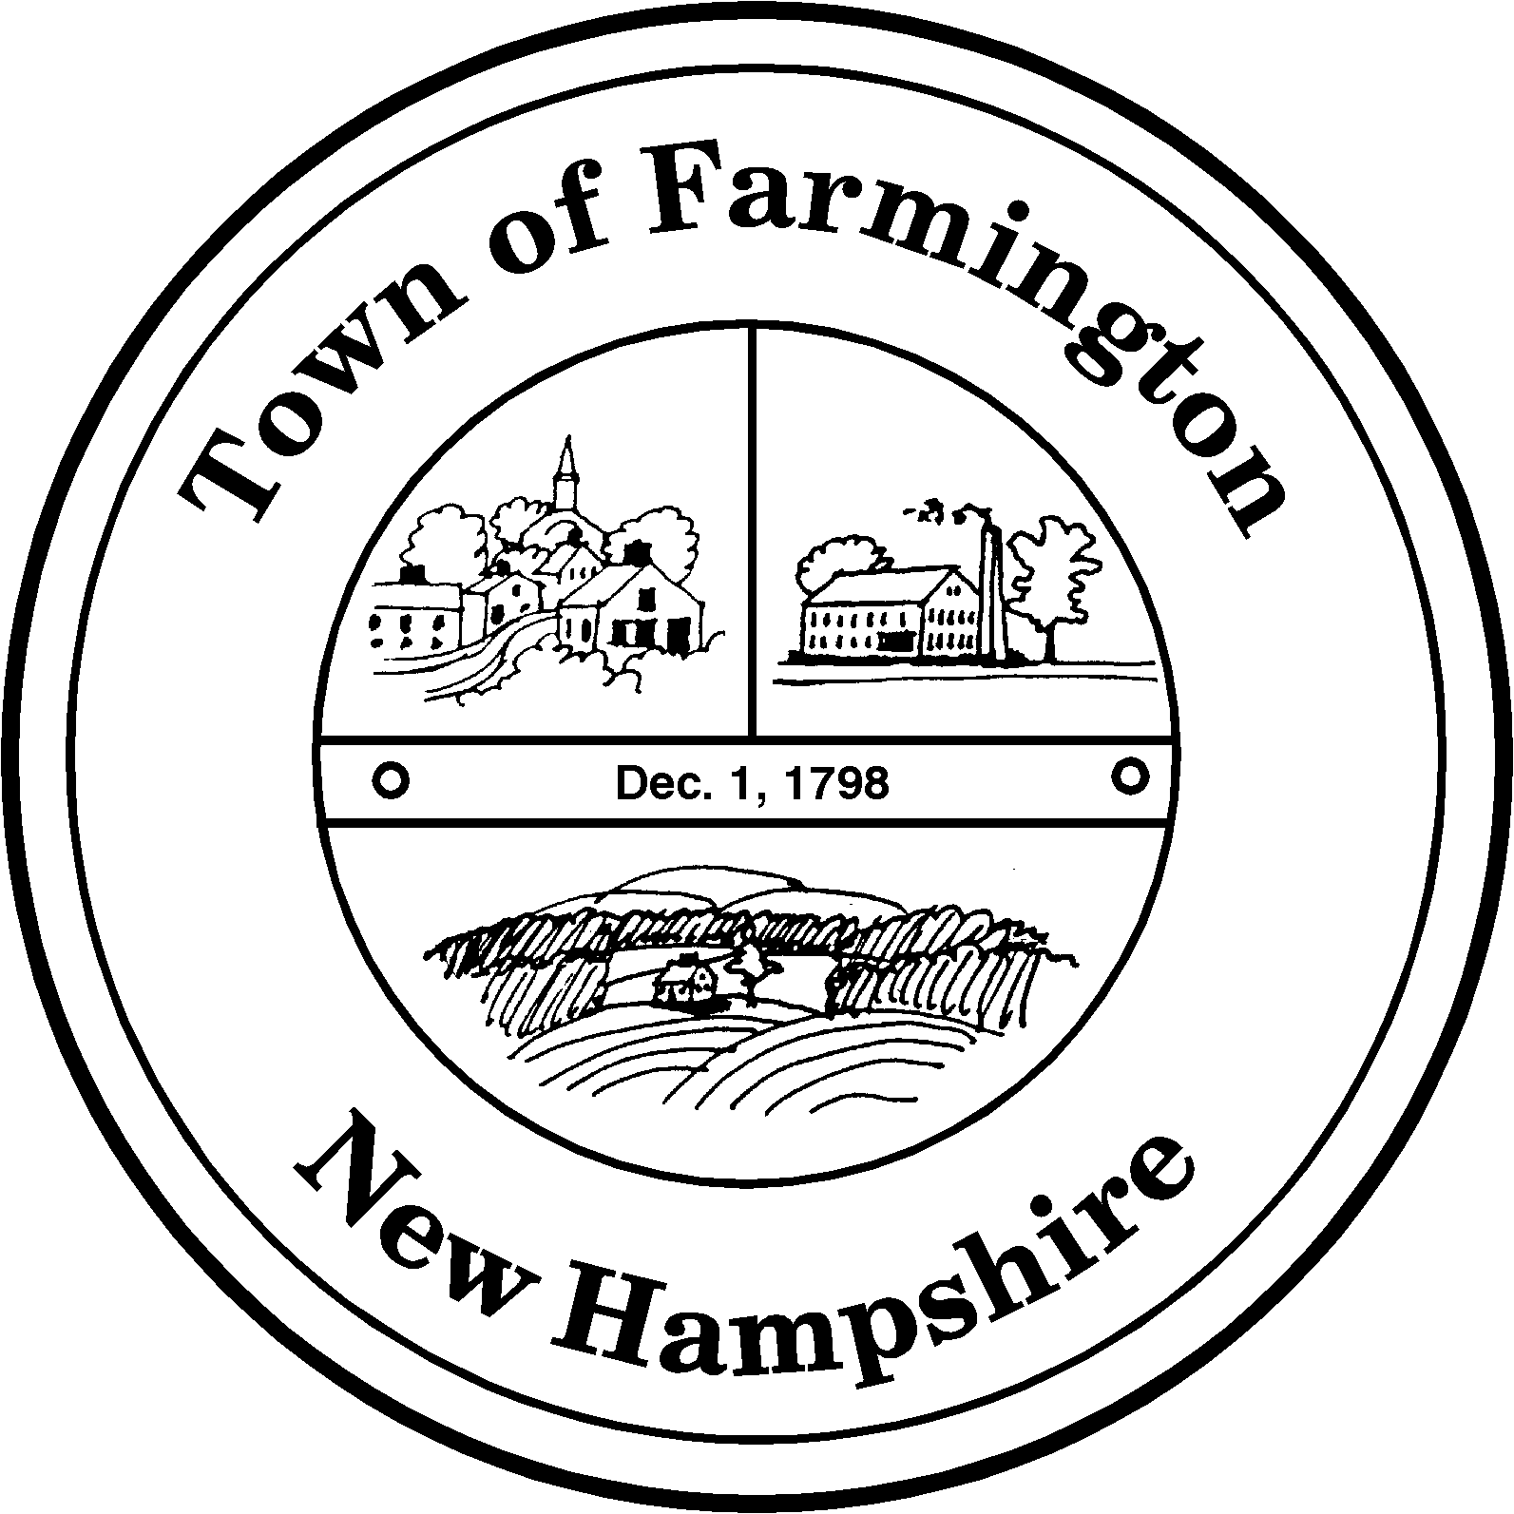
Town of Farmington
Planning and Community Development
356 Main Street
Farmington, NH 03835
Phone: (603) 755-2774
A Bicentennial Community
1798 - 1998

PLANNING BOARD WORKSHOP MEETING

TUESDAY – August 02, 2011

356 Main Street - Farmington, NH

AGENDA - 6:00 p. m.

BUSINESS BEFORE THE BOARD:

- Pledge of Allegiance

- Review and approve Meeting Minutes of July 19, 2011

- Update re: CAC International LLC – Richards Way

- Update re: Stamatia Minimas – 498 Main St.

- Continued discussion re: proposed zoning amendment for Lancelot Shore

- Discussion re: proposed zoning amendment - Small Wind Turbines

- Any other business to come before the board.

Paul Parker, Chairman,

Farmington Planning Board

